
STARTERS

Crab, Prawn & Crayfish Cocktail
Bloody Maryjelly, avocado
£8.00

Seared Scallops
Cauliflower pakora, curry, red pepper coriander tuille
£10.50

Venison Carpaccio
Beetroot puree, kale, walnut pesto & Pecarino straw
£7.50

Pressed Ham & Chicken Terrine
Remoulade, black pudding ketchup, pickled shallots
£7.50

Goats Cheese & Hazelnut
Salsafy chips, pink peppercorn salsa
£7.50

Hot Smoked Salmon
Sourdough crumpet, caviar butter, poached egg, hollandaise
£8.50

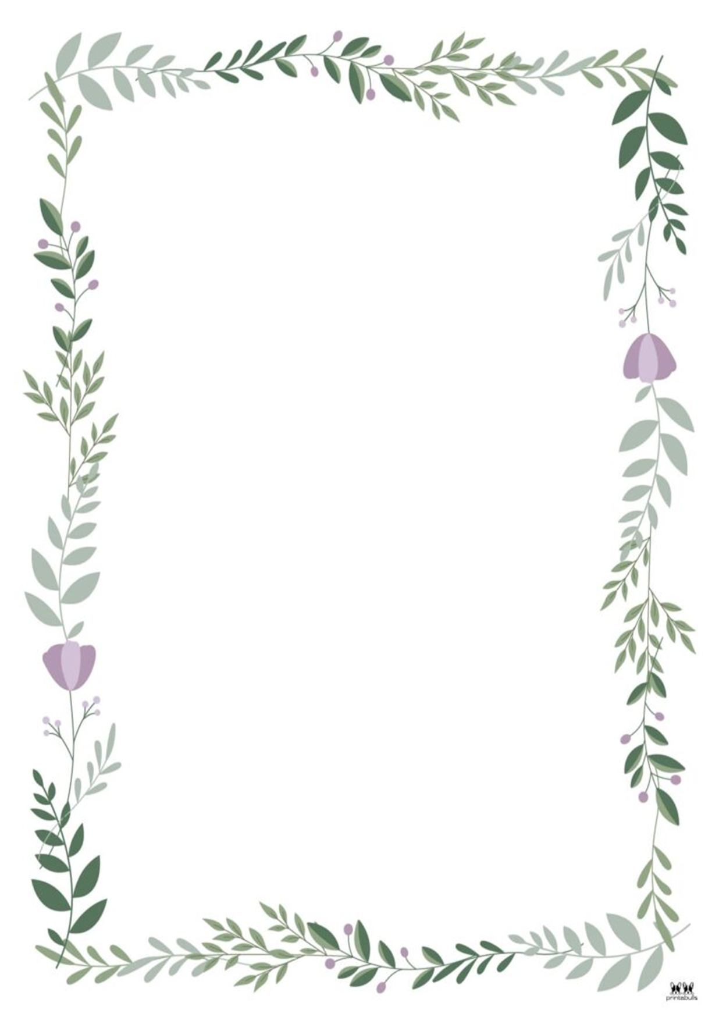
MAIN COURSES

Scrumpy Pork Belly
Fennel, champ potatoes, carrot puree
£19.50

Lamb Trio
Braised neck croquette, rolled shank, saute noisette, Swiss chard, chervil,
lamb breast crisp
£22.50

Halibut & Marmite King Oyster
Burnt shallot, crab cake, tarragon veloute maitake
£28.00

Ox Cheek Bourguignonne
Pearl barley broth, tenderstem
£26.00

Onion Tart
Brown bread, leek & potato terrine, truffle vinaigrette
£20.50

Citrus Brined Chicken Breast
Anna potatoes, celeriac puree, cavalo nero kale, pan gravy
£20.50

Wild Mushroom Risotto
Parmesan Crisp and water cress
£16

FROM THE GRILL

All our grills are served with beef dripping chips,
mushrooms & roasted tomatoes

12 oz Ribeye £39.50

12 oz Sirloin £41.50

10 oz Fillet £45.00

18 oz Pork Tomahawk £32.00

Sauces £3.50:
• Peppercorn
• Red Wine
• Blue Cheese
• Garlic Butter
• Béarnaise

All our beef steaks are locally reared and dry aged.

DESSERTS

Peanut Butter Caramel Tart
Brittle,. chocolate sorbet
£9.00

Pear & Lavender Textures
Sable biscuit, creme Anglaise
£9.00

Sour Apple Souffle
Peach sorbet
£10.50
(Please allow 20 minutes cooking time)

Citrus White Chocolate Dome
Blood orange gel & yogurt sorbet
£9.00

Chefs Cheese Selection
Biscuits, apple, quince, celery & chutney
£12.00

